EXPT NO: 6 | IMPLEMENTATION OF LONG SHORT-TERM MEMORY (LSTM) FOR SENTIMENT ANALYSIS
DATE:

PRE-LAB QUESTIONS (PROVIDE BRIEF ANSWERS TO THE FOLLOWING QUESTIONS)

1. Explain the working of LSTM networks in processing sequential data.
LSTM processes data step by step using memory cells and gates. It remembers important information and learns long-term dependencies in sequences.

2. Why is LSTM suitable for sentiment analysis?
LSTM understands the order of words and learns contextual relationships in sentences, helping classify reviews as positive or negative.

3. Explain the role of memory cells and gates in LSTM.
Memory cells store information, while input, forget, and output gates control what information is stored, removed, and passed forward.

4. Explain the importance of tokenization.
Tokenization divides text into smaller units, usually words or tokens, making it easier to process textual data.

5. Why must text be converted into numerical representations?
Neural networks process numerical data. Therefore, words are converted into integer sequences or vectors before training.

AIM
To implement a Long Short-Term Memory (LSTM) neural network for sentiment analysis and classify textual data into appropriate sentiment categories based on the learned linguistic patterns.

SOFTWARE REQUIREMENTS
- Python
- TensorFlow / Keras / PyTorch
- Google Colab
- GitHub
- NumPy
- Matplotlib
- Pandas

OBJECTIVES
Students will be able to:
- Understand the architecture and working of Long Short-Term Memory (LSTM) networks.
- Understand the role of LSTM in processing sequential textual data.
- Perform text preprocessing techniques for sentiment classification.
- Convert textual data into numerical sequences suitable for LSTM models.
- Build and train an LSTM-based sentiment classification model.
- Evaluate the performance of the trained LSTM using appropriate classification metrics.
- Analyze the effectiveness of LSTM in learning contextual and sequential patterns from textual data.

PROCEDURE
PART A: DATASET PREPARATION
Perform the following tasks:
- Load a suitable sentiment analysis dataset such as the IMDB Movie Reviews dataset.
- Explore the dataset and examine sample reviews and their corresponding sentiment labels.
- Identify the positive and negative sentiment classes.
- Perform basic text preprocessing such as converting text to lowercase, if required.
- Remove unnecessary characters or symbols, if required.
- Tokenize the reviews into words.
- Build a vocabulary and assign unique integer indices to words.
- Convert the text reviews into numerical sequences.
- Apply sequence padding to obtain inputs of equal length.
- Split the prepared dataset into training and validation/testing datasets.

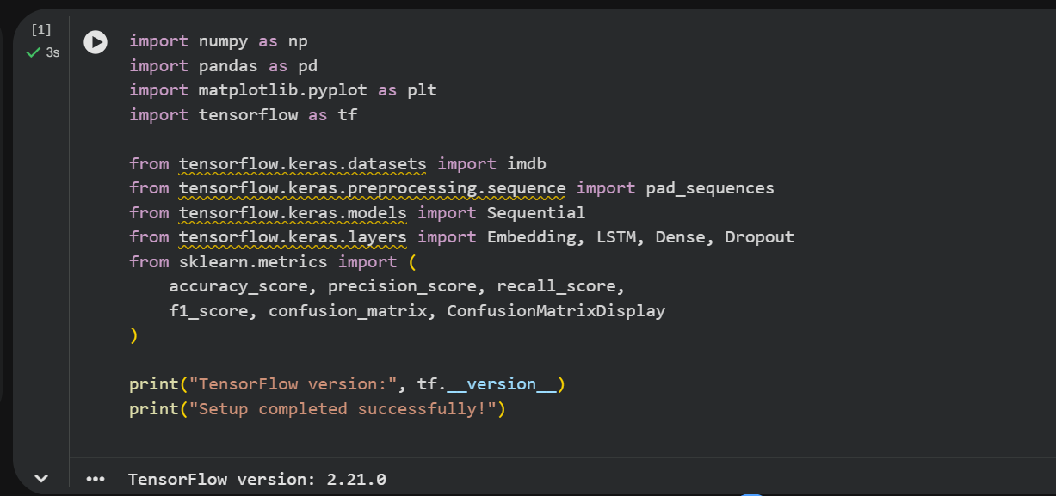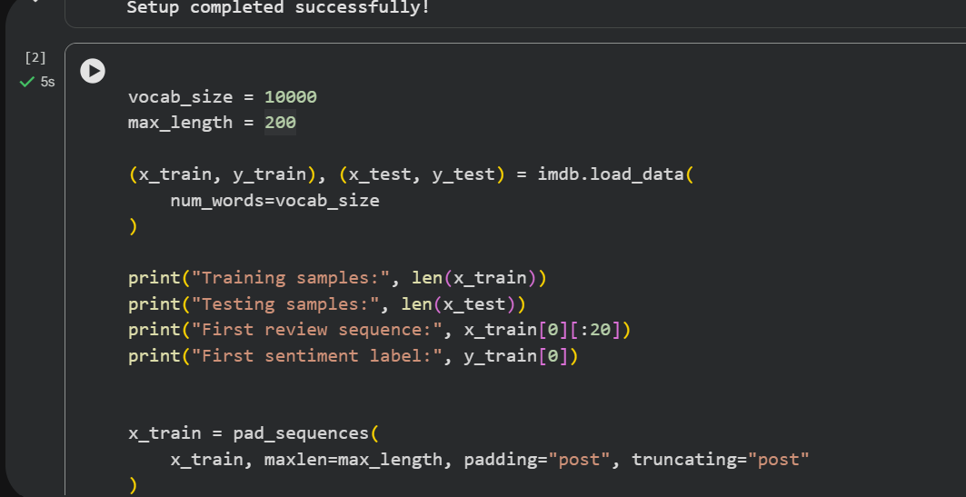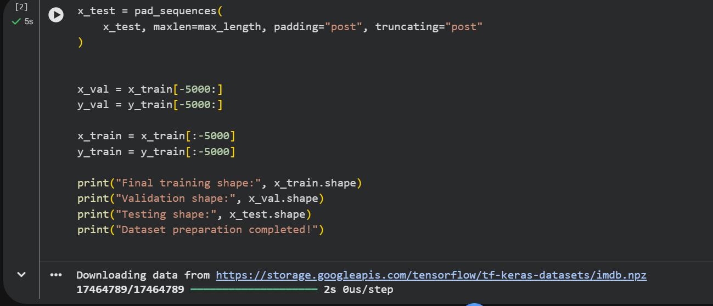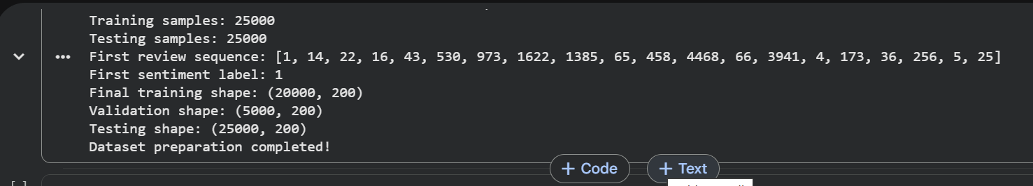PART B: IMPLEMENTING THE LSTM MODEL
Perform the following tasks:
- Create an Embedding layer to convert words into dense vector representations.
- Add an LSTM layer to learn long-term sequential dependencies in the reviews.
- Add a Dense output layer for sentiment classification.
- Use an appropriate activation function such as Sigmoid for binary sentiment classification.
- Compile the model using an appropriate optimizer and loss function.
- Display the model architecture and model summary.

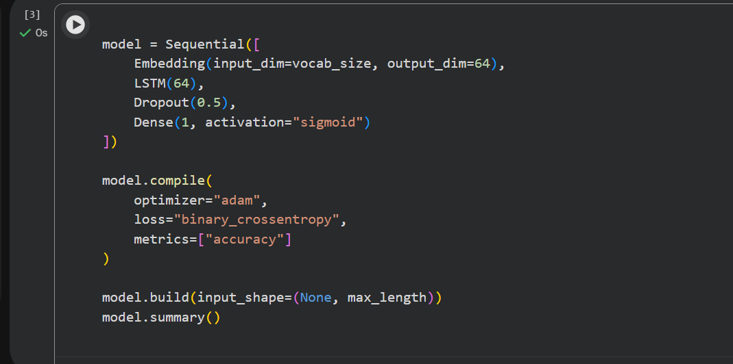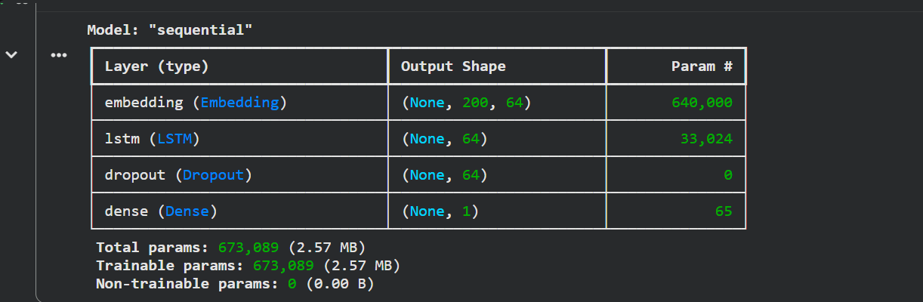PART C: MODEL TRAINING AND PERFORMANCE EVALUATION
Perform the following tasks:
- Train the LSTM model using the prepared training dataset.
- Validate the model using the validation dataset.
- Record:
  - Training accuracy
  - Validation accuracy
  - Training loss
  - Validation loss
- Evaluate the trained model on the test dataset.
- Calculate suitable evaluation metrics such as:
  - Accuracy
  - Precision
  - Recall
  - F1-score
- Generate a confusion matrix to analyze the classification performance.
- Visualize:
  - Accuracy vs. Epoch
  - Loss vs. Epoch

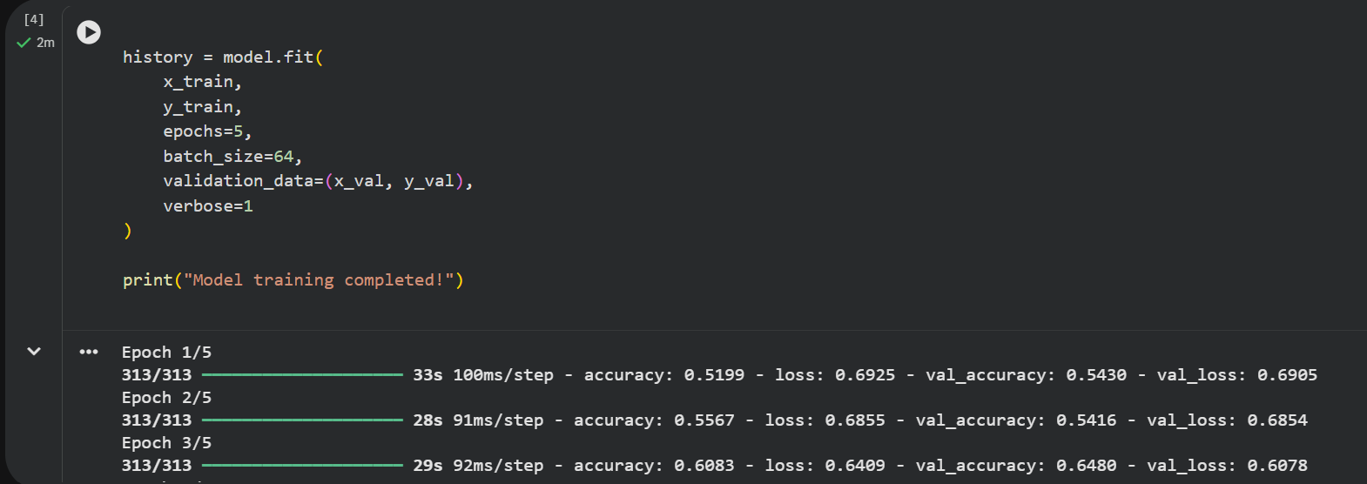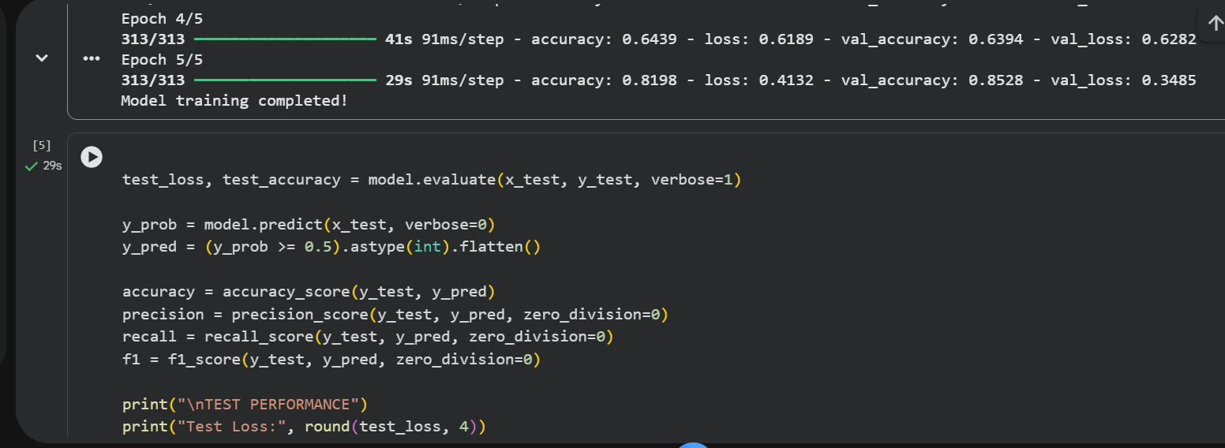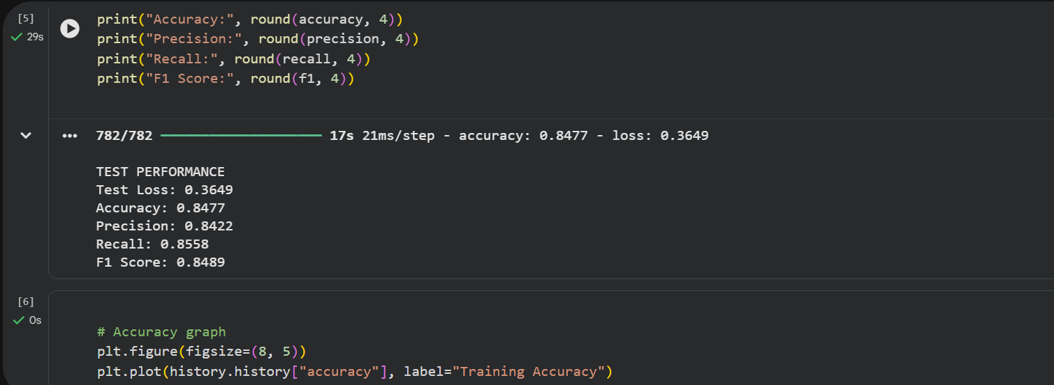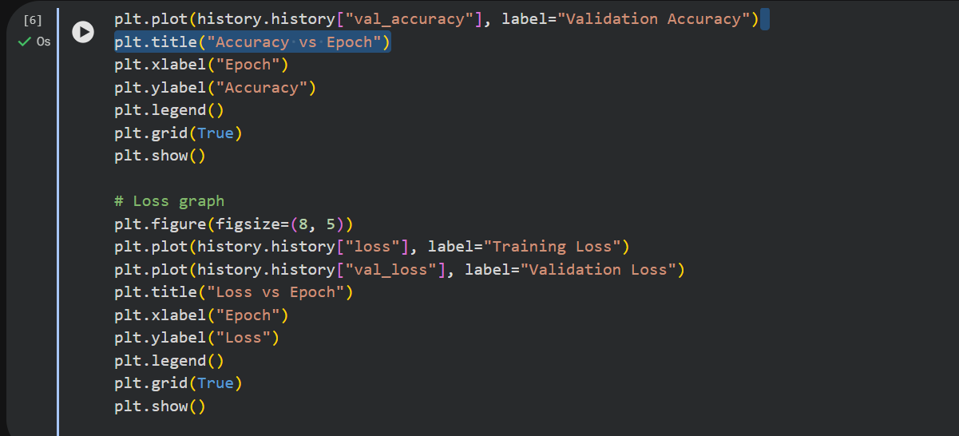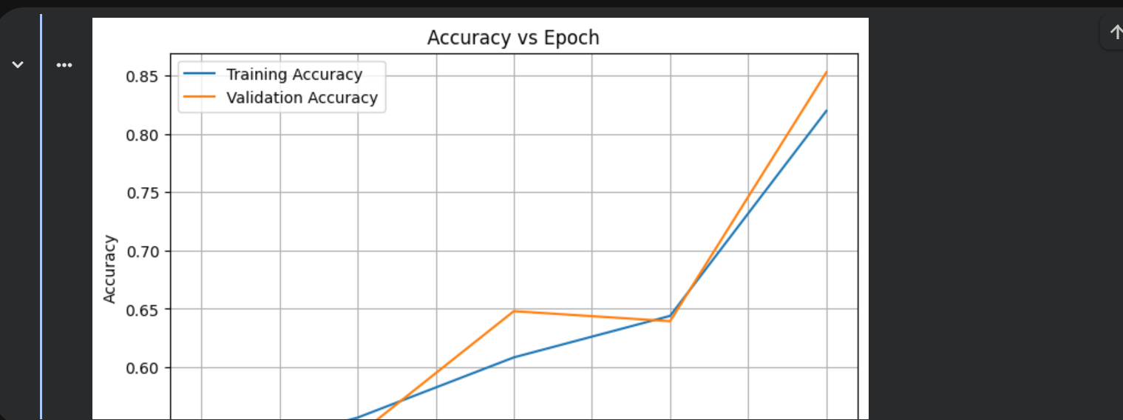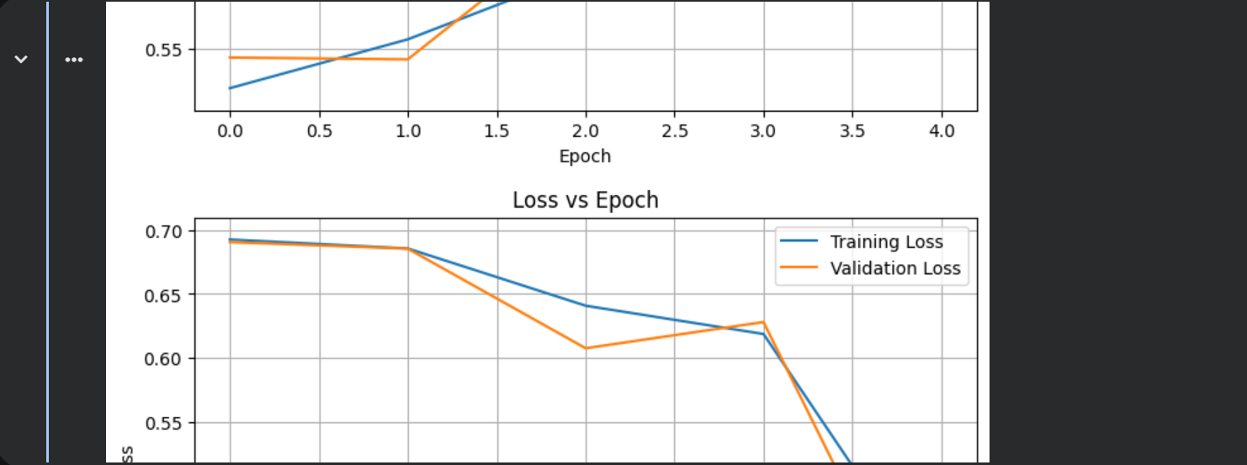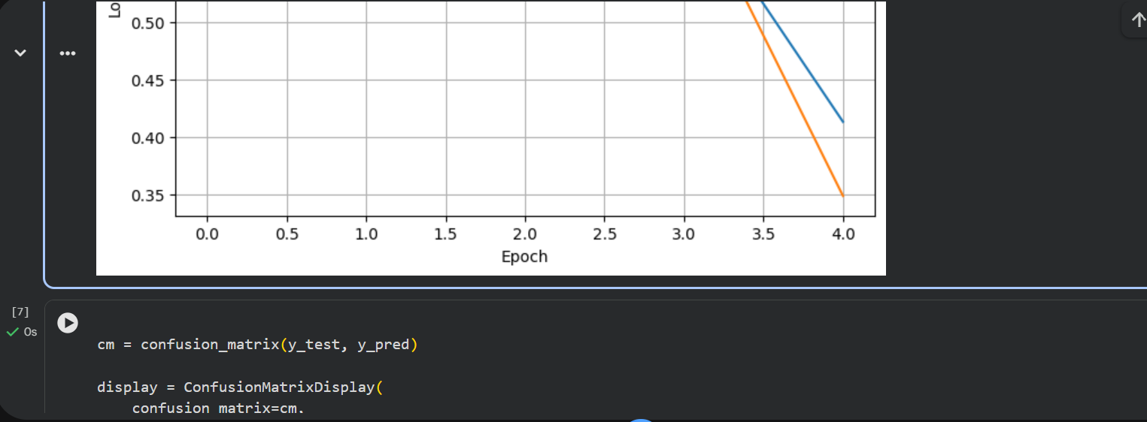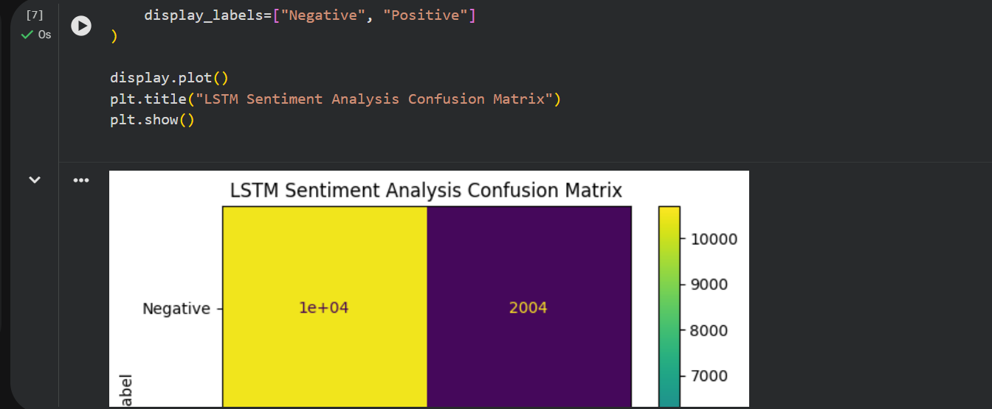
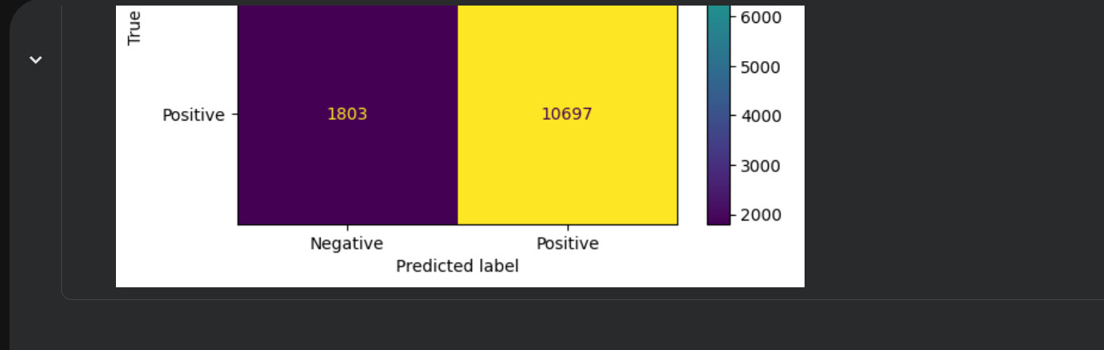PART D: SENTIMENT PREDICTION AND DEEP LEARNING EXPERIMENT MANAGEMENT

Perform the following tasks:
- Provide new movie-review sentences as input to the trained LSTM model.
- Preprocess and tokenize the input text using the same vocabulary used during training.
- Apply sequence padding to the input text.
- Predict the sentiment using the trained LSTM model.
- Classify the input as Positive or Negative based on the predicted probability.
- Provide multiple review samples with different sentiments.
- Compare the predicted sentiment with the actual/expected sentiment.
- Analyze the coherence and correctness of the model predictions.
- Document the observations and upload the notebook to GitHub.

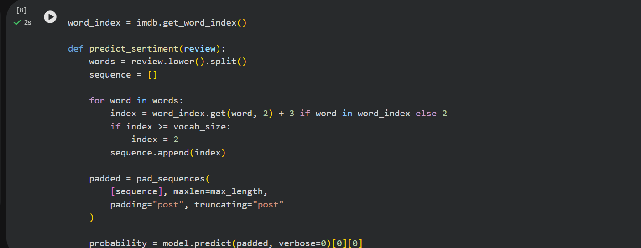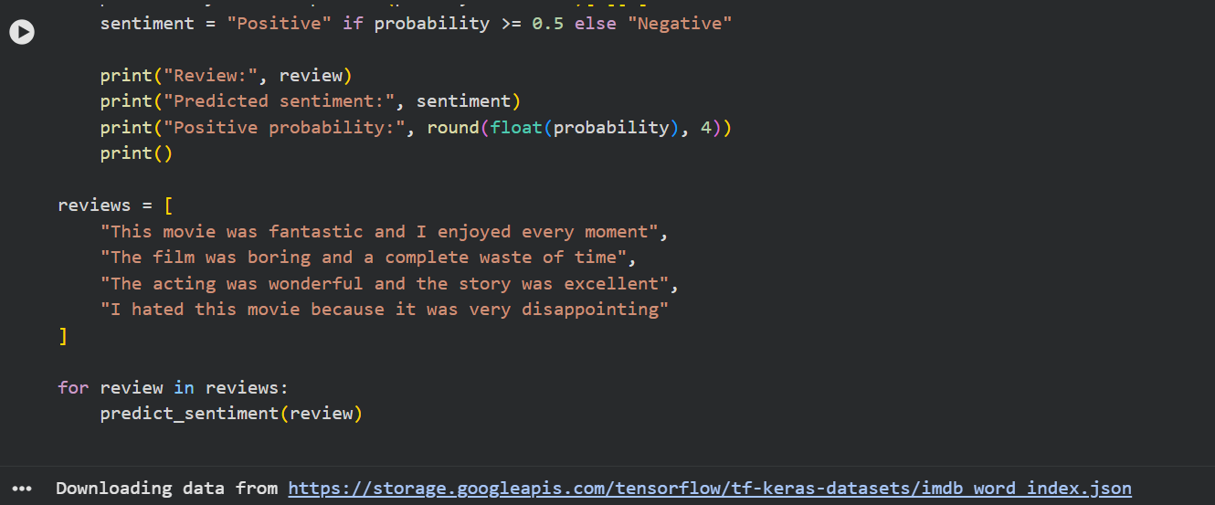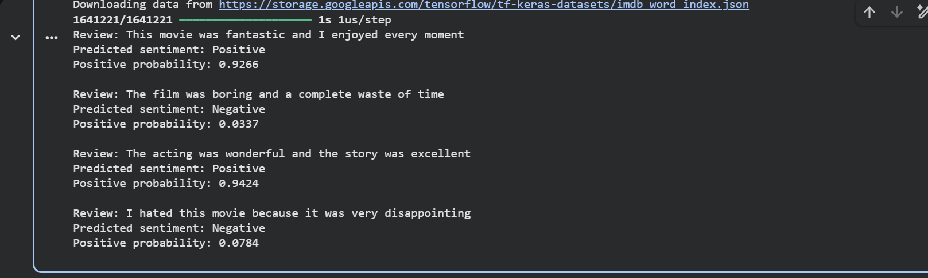

https://colab.research.google.com/drive/1hTsPBlKJEU-CMg-dWnK7Sj5rwAo2tYea?hl=en-GB#scrollTo=9bWSo-r7TikW

POST-LAB QUESTIONS (PROVIDE BRIEF ANSWERS TO THE FOLLOWING QUESTIONS)

1. How does the cell state help an LSTM retain information?
The cell state carries relevant information across time steps, helping the LSTM retain information over long sequences.

2. Describe the three gates in LSTM.
- Input gate: Controls new information entering memory.
- Forget gate: Controls which stored information should be discarded.
- Output gate: Controls which information is passed to the next step.

3. What is the effect of insufficient training epochs?
The model may underfit and fail to learn important patterns, resulting in low accuracy on training and test data.

4. State one advantage of LSTM over a Simple RNN.
LSTM can learn long-term dependencies more effectively and helps reduce the vanishing gradient problem.

5. How does sequence length affect LSTM performance?
Longer sequences can preserve more context but increase computation and training time. Shorter sequences train faster but may lose useful information.

ASSESSMENT
Description | Max Marks | Marks Awarded
Pre Lab Exercise | 5
In Lab Exercise | 10
Post Lab Exercise | 5
Viva | 10
Total | 30
Faculty Signature

